Jolly Phonic Sound Mat

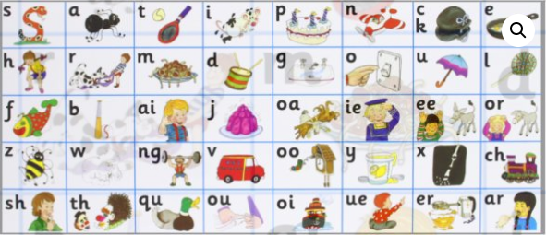

Seven Steps for Success

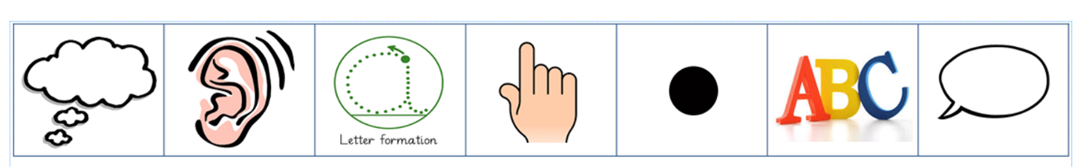
Seven Steps to Success

