Week 3 - Growth of the Railway

This week we have 2 activities for you to complete, the first is a timeline. Cut out the cards and place in chronological order.
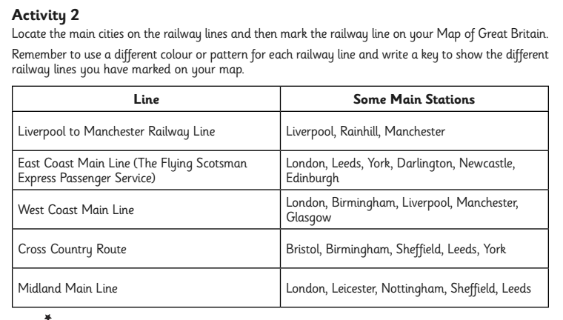
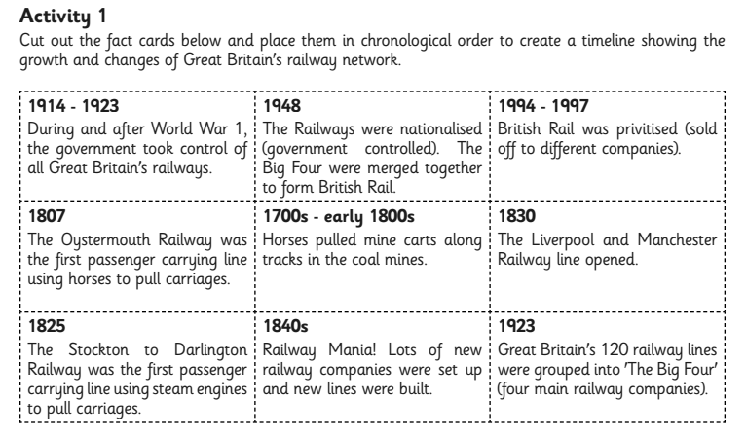
The second activity is slightly trickier. Mark the railway lines on the map you have been given. Unfortunately, we have not shown the location of all the stations named!
Map of Great Britain
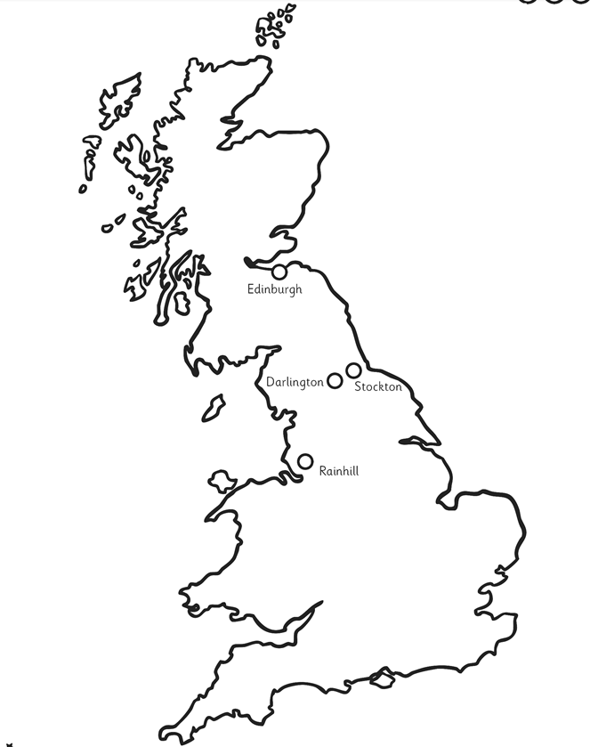
I can describe how and why the railway network in Britain grew and changed over time.

