Are you missing our singing assemblies?
I am!
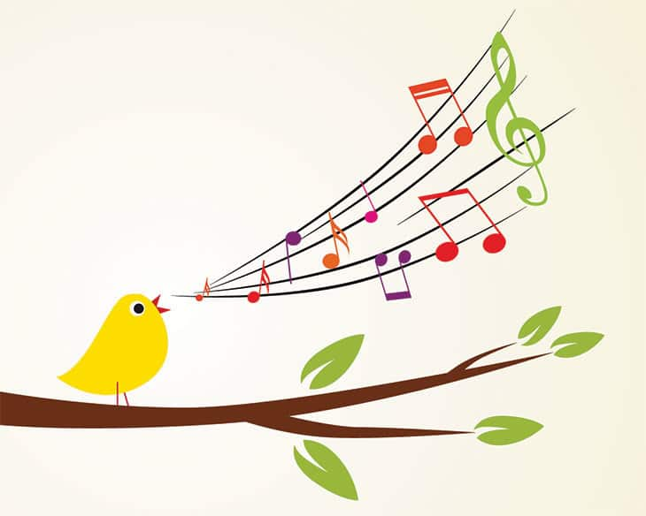
I have put a link below, to a version of the song which I believe was a favourite when we were last singing together in school. It warmed my heart this morning as it reminded me of you all, although I much prefer to hear WJPS children singing it! String group were learning parts for it too and I can’t wait to be back in the hall putting it all together.
This Photo by Unknown Author is licensed under CC BY-SA
Maybe we should ask Miss Smith to sort out some moves for our Dance Club children too?
Hope you enjoy this and make sure you sing along loud and clear. Maybe do our music ladder warm up first, with stamps and claps on the right beats… I wonder if your family can get it right?
Here it is:
https://www.youtube.com/watch?v=FUQheX3PSnY
Don’t forget to keep practising our new song “One Moment, One People.” too. The details are still on our website.

Hear you soon!
Lots of love,
Mrs Hague.

