Dear Parent/Carer,

Please would you tick the relevant boxes below for your child. It is essential that we have the correct dietary and allergy information for your child to prevent them choosing menu options which are not suitable for them.

Name of Child: ……………………………………………………

**Please note unfortunately our meat is NOT HALAL**

What does your child eat? Please tick Yes if they can eat the item and No if they can NOT eat the item.j0149627

BEEF Yes🞎 No🞎

Does your child have any additional food allergies that we should know about?

For example gluten, artificial colouring, fruit or any other allergy – please list them below.

…………………………………………………………………………………………………………………………………………………………………………………………………………………………………………………………………………

Please give us a copy of the letter from your GP confirming any allergies.

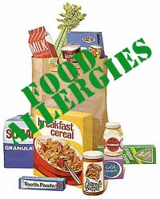

j0299493

PORK Yes🞎 No🞎

j0222009

CHICKEN Yes🞎 No🞎

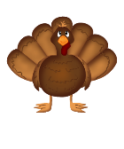

TURKEY Yes🞎 No🞎

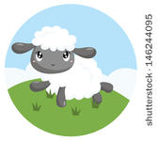

LAMB Yes🞎 No🞎

j0196062

FISH Yes🞎 No🞎

j0215943 EGGS (cooked) Yes🞎 No🞎

EGGS (raw) Yes🞎 No🞎

ie. Mayonnaise/Salad Cream.

Please note, with regards to eggs, the system only allows us to restrict eggs (either cooked or raw) into one category. If your child is allergic to eggs in any form, they will be blocked from choosing a product containing eggs of any sort.

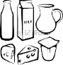

Signed: …………………………………………..

(Parent/Guardian)

Date: …………………………………

DAIRY Yes🞎 No🞎

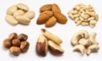 NUTS Yes🞎 No🞎