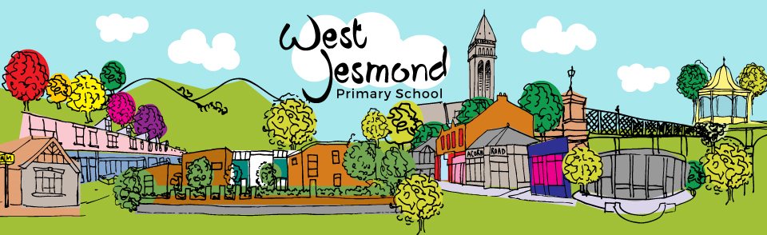
Working Together;
Beginning Writing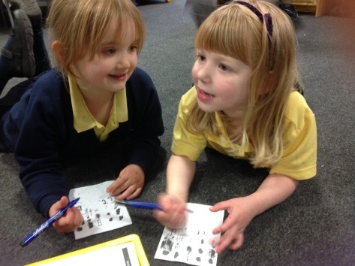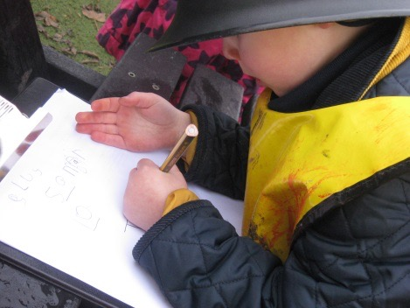 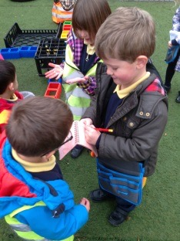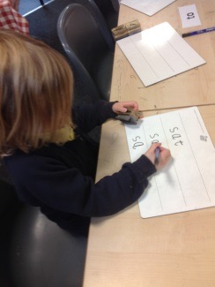
This booklet is to help you understand the different stages of development in children’s writing, how we teach your child to write here at West Jesmond, and hopefully give some helpful tips on how you can support your child at home.
The booklet is designed to run alongside our writing workshop, where we will be explaining all of these aspects a little further.
If you were unable to attend, and need any additional help in understanding how we teach writing, or need some extra ideas on how to support your child at home, please do not hesitate to get in touch with your class teacher, and we will be happy to help.
It is important to remember that all children learn at different rates, all children’s learning has a different starting point, and that children prefer to learn in different ways. What works for one child will not necessarily work for another, and what one child achieves will not be the same for all children.
When reading this information, or taking part in the workshops please do not worry or become anxious, please think about your individual child; where they are now, what the next step will look like for them, and strategies that they will enjoy to help practise their skills.

Thank You

How do we teach writing?

- Our children are taught to spell phonetically - that is, we ask children to ‘sound-out’ a word in order to help them write it down.

- Children are taught to listen for the phonemes in each word – that is, the number of sounds – (eg, hat has 3 phonemes ‘h’ ‘a’ and ‘t’, ship also has 3 phonemes ‘sh’ ‘i’ and ‘p’). We then ask them to write down each sound they can hear, in the correct order.

- Children are also taught the grapheme (written letter) that represents each sound. Sometimes a grapheme is represented by just one letter (as in ‘a’or ‘t'), sometimes a grapheme is represented by 2 or 3 or more sounds, such as ‘sh’ or ‘igh'

- Children are taught to listen carefully to a word, break it down into its sounds, and show those sounds using the graphemes we have taught.

- Children are not taught specific spellings in these early stages, although as your child becomes a more fluent reader, they will become so familiar with high frequency words that they will be begin to write them correctly – such as ‘the’, ‘of’ or ‘said’.

End Of Year Writing Expectations for Reception
Please remember, that this is where we hope most of our children will be by the end of the summer – lots of children are only just beginning on this journey.
By the end of Reception, we will be able to:
- Write all of our letters correctly, starting and finishing in the right place.
- Hold my pencil in a pincer grip.
- Write between two lines.
- Write words using the phonics I know.
- Write some irregular words correctly, such as 'the' and 'of'.
- Know that there are spaces between words.
- Know that there are capital letters and that they are used to start a sentence.
- Write a simple sentence that I can read back to myself, and that can be read by a grown-up.
An example of Reception writing at the end of the year:
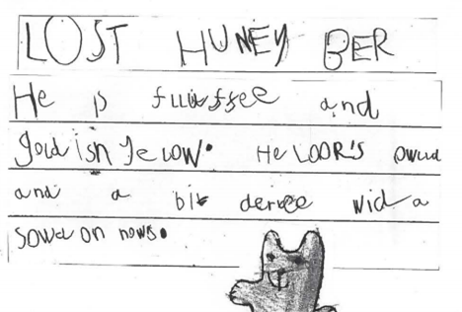

Laying the foundations for writing

In order for children to be able to write, they need a variety of skills to help them.
- Firstly, they need an idea – a reason to write. Children are motivated the most to write when it has a purpose and fits into their play or daily routines. Letters, shopping lists, birthday cards, labels for their bedroom door, holiday journals are all good examples.
- Secondly, children need to be clear on exactly what they want to communicate in their writing. It is important they have the chance to practise saying their idea out loud first – making sure it 'sounds' right and that it makes sense. If they can't say it, they can't write it.
- Children also need to be physically able to write, and this is where development of the childrens' fine motor skills is so important. Children need to be able to hold a pencil (or pen, chalk, paintbrush, crayon) and move it correctly to make the letter they want.
- Reading is an incredibly important foundation for writing. The more children read, and are read to, the more familiar they are with the concept of language – how it flows, how sentences work, how ideas link together. They also ‘see’ writing – they see there are spaces between words, there are capital letters and full stops, and that each word carries meaning and links to the next. Reading also gives lots of ideas for writing – children have a bank of story language and a wider vocabulary the more they read, allowing them to think of more things to say in their own writing.
- And finally, children need to be continuing to develop their phonics skills. In order for children to write, they need to be able to hear the sounds in the words they are writing, and how to make that sound with a letter, or collection of letters.

Creating an environment for writing; how can you help make writing part of your everyday life?

- Make writing an everyday part of life where writing shown as an important part of how to communicate with others. How often do your children see you write? Where you do write, take the opportunity to include your child, or talk to them about what you are writing.

- Write to your child, or ask others to send postcards or letters. How exciting for them to receive their own letter! You could even just leave them secret notes, or even a message on a banana!

- Provide real opportunities and audiences for your child's writing – writing to the tooth fairy, or writing a menu for dinner, or the shopping list.

- Provide space and equipment for your child to write. Often a novelty pencil or pen is enough to encourage even the most reluctant writer. Or a little notepad or pack of post-it notes has endless opportunities.

- Look for chances to make take writing away from just a pencil and a piece of paper. Writing can happen anywhere and with anything – writing with sticks in mud and sand, writing in steam from the bath, magnetic letters, writing in shaving foam.

- Above all, have fun! See this early writing as the beginning of a wonderful journey. Praise everything your child does in these early stages, no matter what it looks like or if the spelling seems bizzare!

Sounds we will be learning this year:
These are the sounds we will teach the children in Reception – we will ask them to use these when sounding words out.
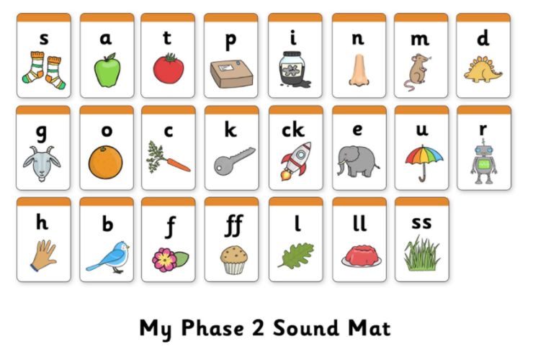
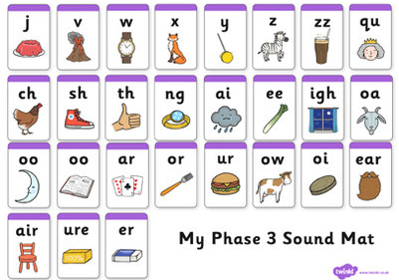

Developing Fine Motor Skills
In order for children to be able to hold a pencil correctly, and to have the strength to write for longer periods, it is important that they are given the opportunity to build up the muscles in their hands and fingers. These are some great ways to do this;

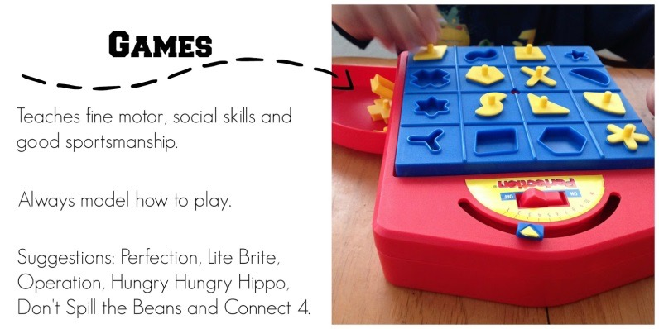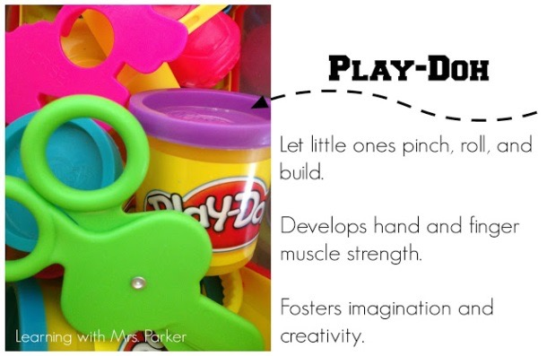
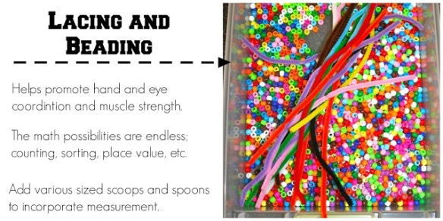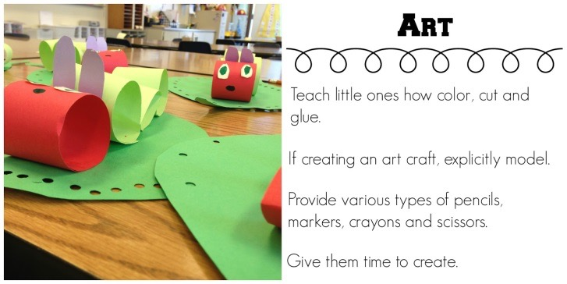

- Cutting
- Threading
- Nuts and bolts
- Pegs on the washing line
- Popping bubbles
- Finger rhymes and songs
- Cooking – making dough
- Screwing and unscrewing bottle tops
- Hole punch and staples
- Wrapping elastic bands around tubes
Letter formation – a quick reminder

Alongside getting our children to be excited about writing, we also want to teach them correctly from the very beginning. Children often find the most magical ways to form their letters, and although they can often end up looking the same shape, they have not formed them correctly.
When your child is writing, gentle reminders about where to begin letters, and about keeping their pencil on the page when writing, are very helpful in building up good habits. Forming letters correctly allow children to write with more fluency and ease, as well as helping them in Key Stage 1 when they will learn how to join letters.

a b c d e f g h i j k l m n o p q r s t u v w x y z
Children should be holding their pencil in a pincer grip. If your child is struggling, again, gentle reminders given to them on how to hold their pencil will stop bad habits becoming the norm, or perhaps you could try using the peg or cotton ball trick. Children sometimes find using a felt tip pen easier in the beginning, as it takes less pressure to make a mark on the paper, making it easier to write with.
