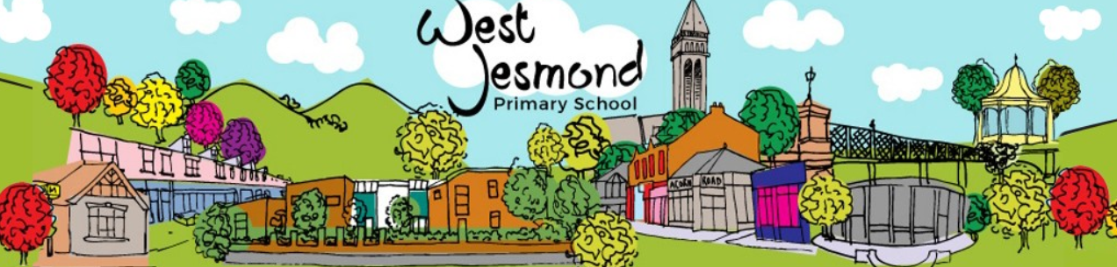
Learning Project WEEK 6 - Food
Age Range: Y3/4
Weekly Maths Tasks (Aim to do 1 per day) | Weekly Reading Tasks (Aim to do 1 per day)
- Working on Times Table Rockstars  - If your child works on ‘Numbots’  in school they can access this with the same login.  - Play on Hit the Button - focus on number bonds, halves, doubles and times tables.  - Adding totals of the weekly shopping list or some work around money. This game could support work on adding money. (You may need to enable Flash Player).  - Practise telling the time. This could be done through this game (scroll down to access the game). Read to the quarter hour and the nearest 5 minutes.  - Get a piece of paper and ask your child to show everything they know about Time. This could be pictures, diagrams, explanations, methods etc. They can be as creative as they want to be.  - Have a go at some Time worksheets (see WJ website resources).  - Practise counting forwards and backwards from any given number in 3s. | - You could share a story together. This could be a chapter book where you read and discuss a chapter a day.  - Listen to your child read and let them discuss what they have read. Encourage them to read with expression and intonation.  - Get your child to read a book on Oxford Owl, discuss what your child enjoyed about the book.  - Get your child to read a book on Epic! and if applicable answer the questions at the end.  - Explore new vocabulary you find when reading. What are the origins of this word? Can it be modified? Can you find any synonyms or antonyms for your new word?  - With your child, look in magazines, newspapers and books for new vocabulary they are unfamiliar with.  - Have a go at the comprehension questions about the Railway Children (see WJ website resources).
Weekly Spelling Tasks (Aim to do 1 per day) | Weekly Writing Tasks (Aim to do 1 per day)
- Practise the Year 3/4 for Common Exception words.  - Have a go at some of the online spelling games (see WJ website resources).  - Choose 5 Common Exception words. Write a synonym, antonyms, the meaning and an example of how to use the word in a sentence. Can the word be modified?  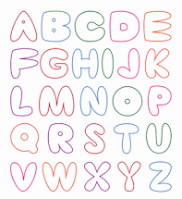  - Choose 5 Common Exception words and practise spelling them using bubble letters. Write the word in bubble letters, e.g. | - Write a recount to a family member telling them all about how your day or week has been.  - Work on the Talk 4 Writing project (see WJ website resources).  - Write a recipe. How to make ……..  Remembering to include a list of ingredients and things they need. Also not forgetting to include headings and subheadings. Then write their set of instructions, remembering to include imperative verbs. (Verbs that command you to do something).  - Write a review about a meal they’ve eaten. Describe what they had to eat. What did they enjoy and why?  - Choose a particular food and write an acrostic poem. Think about where it comes from? What does it look like? What does it taste like? Etc….  - Take part in a Pobble writing challenge.
Learning Project - to be done throughout the week
The project this week aims to provide opportunities for your child to learn more food. Learning may focus on where different foods originate from, what makes a healthy meal, opportunities to cook etc.

- Let’s Wonder:

What is a balanced diet? Find out about the 5 food groups. Make slides or
posters about what they find out about. Carbohydrates Protein Dairy Fruits and
Vegetables Fats. Where does their food come from? Which foods come from the UK?
What is fairtrade?

- Let’s Create:

Make repeated pattern prints for decorative purposes using various natural materials, e.g potato printing or create some still life observational sketches of fruit. Look at the artwork of Giuseppe Arcimboldo Maybe recreate some of his paintings with fruit.
- Be Active:

Food provides us with energy and we need energy to exercise and this keeps us fit. Why not choose a dance from Supermoves?
Recommendation at least 2 hours of exercise a week.

- Time to Talk:
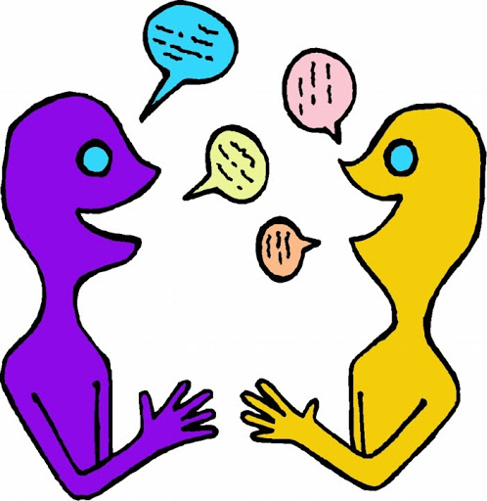
As a family, design a healthy meal plan for the week. Discuss their favourite foods and why they enjoy them? Talk about healthy and unhealthy foods and explain the importance of eating a balanced diet.

- Understanding Others and Appreciating Differences:

Lunch around the world. Look at lunch around the world and investigate how differently people eat in other parts of the world. Find out what a vegetarian is? Vegan? Kosher food?
Halal food?

- Reflect:

Make a meal by combining a variety of ingredients using a range of cooking techniques.
Measure and weigh ingredients appropriately to prepare and cook a range of savoury dishes.

Additional learning resources parents may wish to engage with
Classroom Secrets Learning Packs - These packs are split into different year groups and include activities linked to reading, writing, maths and practical ideas you can do around the home.
Twinkl - to access these resources click on the link and sign up using your own email address and creating your own password. Use the offer code UKTWINKLHELPS.
Headteacherchat - This is a blog that has links to various learning platforms. Lots of these are free to access.
#TheLearningProjects

