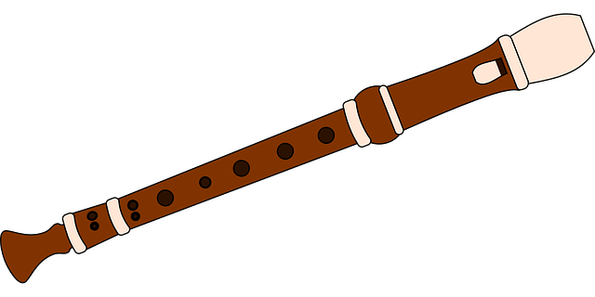

For those of you who have been following my recorder lesson videos on our school Facebook page, I would like to introduce you to some extra resources to help you to develop your recorder playing and your music notation reading skills.
Please follow the link below to access Visual Musical Minds Interactive Recorder lessons…
https://www.youtube.com/watch?reload=9&v=m4xdxlGc5Fo&list=PLzPP1Evz0WkQkPXJMWk0c64KPBssoljyg
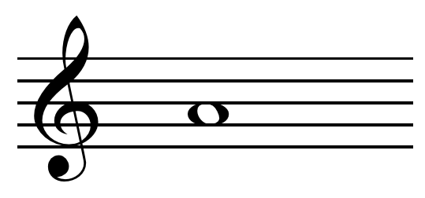

Have fun!
Mrs.Hague.

