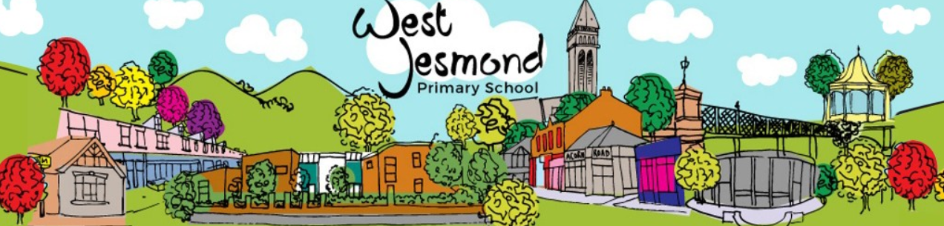
Learning Project WEEK 5 - Environment
Age Range: Y3/4
Weekly Maths Tasks (Aim to do 1 per day) | Weekly Reading Tasks (Aim to do 1 per day)
- Working on Times Table Rockstars  - Play on Hit the Button - focus on number bonds, halves, doubles and times tables.  - Adding totals of the weekly shopping list or some work around money. This game could support work on adding money.  - Practise telling the time. This could be done through this game (scroll down to access the game). Read to the quarter hour and the nearest 5 minutes.  - Have a go at a Time worksheet (see WJ website resources)  - Get a piece of paper and ask your child to show everything they know about Shape. This could be pictures, diagrams, explanations, methods etc. They can be as creative as they want to be.  - Practise counting forwards and backwards from any given number in 5s. | - You could share a story together. This could be a chapter book where you read and discuss a chapter a day.  - Listen to your child read and let them discuss what they have read. Encourage them to read with expression and intonation.  - Get your child to read a book on Oxford Owl, discuss what your child enjoyed about the book.  - Get your child to read a book on Epic! and where possible answer the questions at the end.  - Explore new vocabulary you find when reading. What are the origins of this word? Can it be modified? Can you find any synonyms or antonyms for your new word?  - With your child, look in magazines, newspapers and books for new vocabulary they are unfamiliar with.  - Have a go at the Railway Children comprehension tasks. (See WJ website resources).
Weekly Spelling Tasks (Aim to do 1 per day) | Weekly Writing Tasks (Aim to do 1 per day)
- Practise the Year 3/4 for Common Exception words.  - Have a go at one of the spelling games (see WJ website resources).  - Choose 5 Common Exception words. Write a synonym, antonyms, the meaning and an example of how to use the word in a sentence. Can the word be modified?  - Choose 5 Common Exception words and practise spelling them using across and down. Write the word across the page then down the page, e.g  s p e l l i n g  p  e  l  l  i  n  g | - Write a book review for one of the books they have read. Remember to say what they have enjoyed or not and who they would recommend the book to?  - Draw a scientific diagram of the water cycle then add labels and captions to explain how it works.  - Work on the Talk 4 Writing project (see WJ website resources).  - Have a go at a Pobble writing task.  - Have a go at our Humanities task and think how you would interview George Stephenson! (See WJ website resources).
Learning Project - to be done throughout the week.
The project this week aims to provide opportunities for your child to learn more about the environment. Learning may focus on changes to different environments, the impact of humans on environments, climate change etc.

- Let’s Wonder:

What is the weather like around the world? Which countries are most likely to have a
snowstorm, torrential rain, heatwaves etc….. Find out about natural disasters such as
forest fires, earthquakes, tsunamis, floods, tornados etc….. How is climate change having
an effect on the weather and natural disasters?
- Let’s Create:

Using recycled materials design and make a recycling mascot to spread the word about the importance and need to recycle. Think about what it is going to look like? Which materials are they going to use? How are they going to join the materials together? Once completed, remember to evaluate their mascot. What would they do differently next time? Which parts did they find the most challenging and why?

- Be Active:

Get into the garden and practise throwing and catching skills and keeping control of ball-based equipment like bats and balls.
Recommendation at least 2 hours of exercise a week.

- Time to Talk:

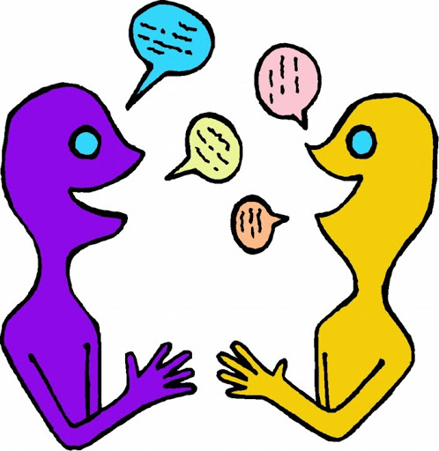
Discuss environmental issues in the UK. Air pollution, climate change, litter, waste, and soil contamination are all examples of human activity that have an impact in the UK. What are the global environmental issues? Various processes that can be said to contribute to the global environmental problems include pollution, global warming, ozone depletion, acid rain, depletion of natural resources, overpopulation, waste disposal and deforestation ... These processes have a highly negative impact on our environment. Decide as a family how they could ‘do their bit’ to look after their environment e.g. you could set up a recycling station in their home; Paper, plastics and glass.
- Understanding Others and Appreciating Differences:

Throughout our lives, culture and experience shapes worldviews, children growing up in the Netherlands, for example, have a much different understanding of the role of water in their lives than their peers in the Sahara Desert. The difference between the abundance and scarcity of water in each of these physical environments affects every aspect of their respective cultures, including the global perceptions they will carry with them throughout their lives. Think about food. How do they think people view food in the UK compared to those living in Ethiopia for example? Research a country where food and water are scarce. Find out about charities that help people in need, Red cross, Christain Aid, Islamic Relief or other charities that are significant to them.
Additional learning resources parents may wish to engage with
Classroom Secrets Learning Packs - These packs are split into different year groups and include activities linked to reading, writing, maths and practical ideas you can do around the home.
Twinkl - to access these resources click on the link and sign up using your own email address and creating your own password. Use the offer code UKTWINKLHELPS.
Headteacherchat - This is a blog that has links to various learning platforms. Lots of these are free to access.
#TheLearningProjects

