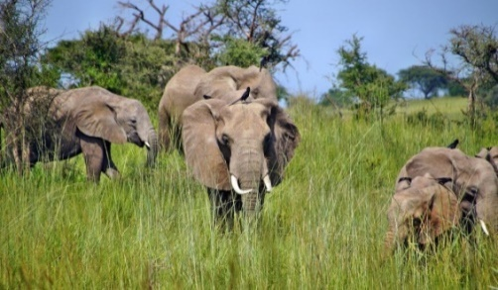
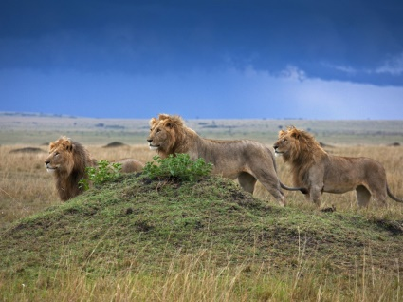
The African Savannah

Here are some stories that you might like to read and share with your children linked to this topic.
One of our favourite stories is ‘Handa’s Surprise’. The illustrations in this book are wonderful. You might like to use them as your inspiration to create your own versions.
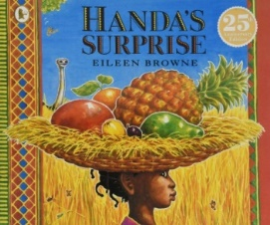 https://www.youtube.com/watch?v=QqdXBhyORug
Rumble in the Jungle
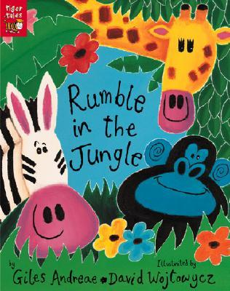 https://www.youtube.com/watch?v=D2-O1LkCzpM

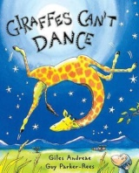
‘Giraffe’s Can’t Dance’
https://www.youtube.com/watch?v=vZjsLK5vwNU

Here is a selection of factual programmes about the African savannah but there are many more to look at:

* LION * | Animals For Kids | All Things Animal TV

https://www.youtube.com/watch?v=qnaXJf_yaj8

* ELEPHANT * | Animals For Kids | All Things Animal TV

https://www.youtube.com/watch?v=CP5uJVpHrVw

Life on the African Savanna

https://www.youtube.com/watch?v=9bQNRVyI4I0

Andy's Wild Adventures: Meet the Elephants in Kenya
https://www.youtube.com/watch?v=v-AZ-jCgUyw
Andy’s Wild Adventures: Meet the Elephant Shrews
https://www.youtube.com/watch?v=40RvOOVgCv8

Songs:
Down in the jungle Boogie Woogie
https://www.youtube.com/watch?v=dFiqiQlHPwU
The Animal Boogie
https://www.youtube.com/watch?v=25_u1GzruQM

