Working Together;
Beginning Reading

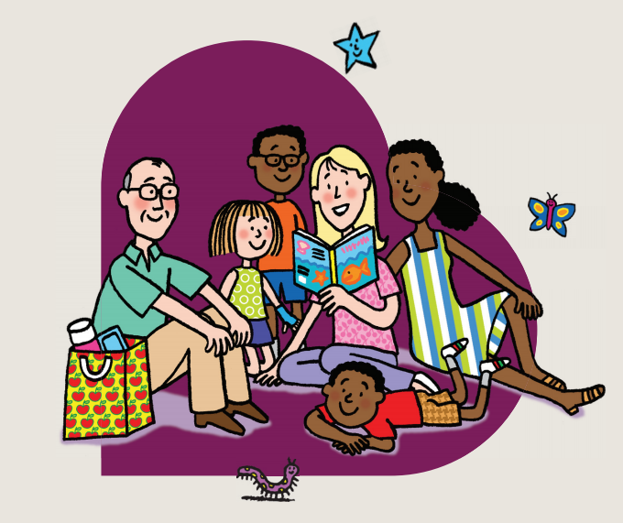

Reading and Phonics Guide for Parents

The aim of this booklet is to give you a clear picture of how we support a love of reading and how we approach the teaching of phonics and word recognition and how as a parent or carer, you can support and encourage your children at home. Reading is made up of a variety of skills including phonics, comprehension, sight word recognition and of course just enjoyment of books!

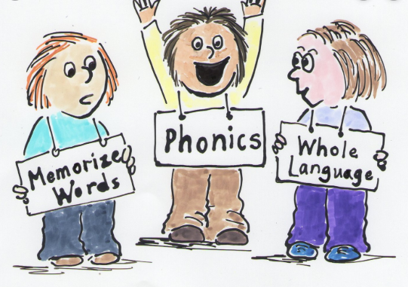

Why is reading so important?

Evidence suggests that children who read for enjoyment every day not only perform better during their time at school, but they also develop a broader vocabulary, increased general knowledge and a better understanding of cultures. It builds confidence and communication skills and of course, it is such a special time to share and bond with your child.

Parents are by far the most important educators in a child’s life, so your support with reading is invaluable. It is the most important ‘homework’ you will ever do with your child.

How can I help my child with their reading?

- Read aloud to your children – even at this point as they start to read for themselves, when you read to your child they hear fluency, expression and enjoyment of books.
- Make books part of family life – always have books around so that your children are ready to read whenever there’s a chance.
- Join your local library – a great resource for keeping interest in books alive. Let them choose their own books to encourage their interests.
- Match their interests – help them find books they enjoy – it doesn’t matter if its fiction, comic books, or non-fiction as long as they engage and enjoy it.
- Get comfortable – Snuggle up somewhere warm and cosy with your child, either in bed, in a beanbag or on the sofa, or make sure they have somewhere comfy when reading alone.
- Ask questions – to keep them interested in the story, ask your child questions such as ‘what will happen next? Where do you think they are? How do you think they are feeling?’ There are questions to ask when reading in the front of your child’s Reading Diary.
- Make sure your child has access to books – perhaps trips to libraries or bookshops to find new books to enjoy. Keeping books they love nearby so they can cosy up and enjoy them at any time.
- Read wherever you get the chance – sometimes sitting down to read a book can be a luxury we don’t have, so find opportunities to read outside story time such as labels at the supermarket, letters, newspapers, street names
- Read again and again – encourage your child to re-read favourite books and poems. Re-reading helps to build up fluency and confidence.
- Bedtime stories – regularly read with your child or children at bedtime. It’s a great way to end the day and to spend valuable time with your child.
- Have fun! This is an exciting journey to go on with your child, so enjoy it.

Understanding phonics
With phonics, children are taught to read by learning the phoneme (the sound) that is represented by a letter. For example the sound sssssssssssss is made when we see the letter s.
Once children build up this knowledge, they are taught to read words by blending these sounds together. For example, teaching children the sounds /t/, /p/, /a/, /i/ and /s/ early on allow them to read words such as tap, tip, pat, sip, sat and it by blending the individual sounds together to make the whole word. Blending the sounds they read is the most important skill the children will need to learn for reading. If you can, practise placing letters cards together, sounding them out, and blending those sounds together to read the words.
They also learn that words can be broken down into their sounds. This helps children learn to write words. For example, the word sat has three sounds (phonemes) /s/, /a/ and /t/ which the children listen for and then write down each sound using the correct letter (grapheme) s,a and t.
At West Jesmond we teach phonics following the document Letters and Sounds which dictates the order in which to teach the sounds. We support this with the bright pictures, actions and songs of Jolly Phonics. The colourful images, stories, actions and songs of Jolly Phonics work well in helping our children remember all of the sounds we teach in Reception.
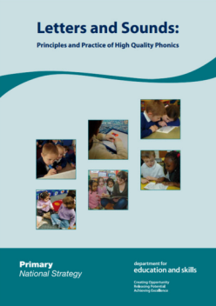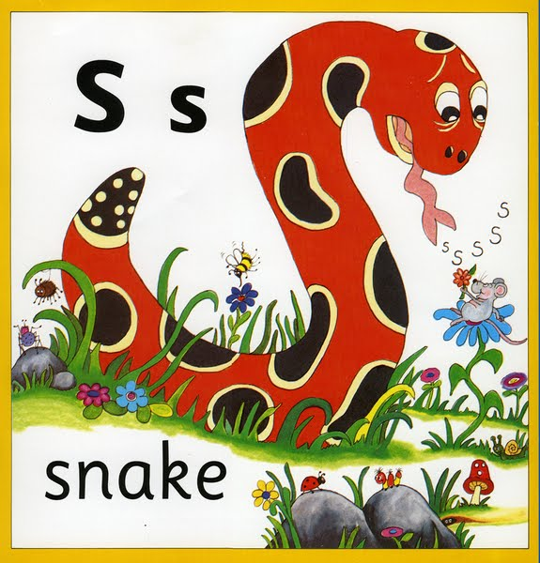
During the Autumn term, we introduce 3 new letters and sounds each week in the following sequence:
s, a, t, p, i. n, m, d ,g, o, c, k, ck, e, u, r, h, b, f, ff , l, ll, ss, j, v, w, x, y, z, zz,
After Christmas, we begin to teach the children diagraphs. This is when two or three letters work together to make one sound.
Consonant digraphs: ch, sh, th, ng
Vowel digraphs: ai, ee, igh, oa, oo, ar, or, ur, ow, oi, er

How can I help my child with phonics?

- Say the sounds correctly – it’s important that the sounds are pronounced correctly, as they would sound in speech. Try to avoid adding ‘uh’ to consonant sounds, such as /t/ and /p/, as this makes it trickier to blend the sounds together.

- Link sounds and letters to make words – children are taught in school to quickly see a link between the phoneme (sound) and a written representation of that sound (grapheme). At home, practise making word with cards or magnetic letters to make words and blend the sounds together.

- Don’t be scared – make it fun – playing games is the best way to engage children as they want to join in and find practising much more entertaining. Hopefully our session will give you lots of ideas.

- Practise – encourage your child to use their phonics knowledge when they are practising their reading. Make sure that they look at each letter in turn, all through each word. Encourage them to work out the sounds and then blend them together to make the whole word. Praise them for trying to use all the letters rather than guessing from just the first letter or the picture.

Tricky Words/ High Frequency Words

Phonics work is a necessary part of learning to read. However phonics alone does not provide the wider knowledge, skills and understanding needed to `take off` as a reader. It is important to secure word recognition skills also. Learning tricky and high frequency words is a vital part of becoming a confident reader. Through building the child’s sight vocabulary it allows them to access an increasing range of books whilst developing fluency, intonation and expression.

There is no easy way to learn High Frequency words – just practise, practise, practise!!

Here are a few ideas for games for you to try at home using simple word cards:

- Stomp – lay the cards out on the floor and ask your child to ‘stomp’ on a chosen word.
- Hide and Seek – hide your tricky words around the room and ask your child to hunt for them.
- Make copies and play ‘snap’
- Shuffle your cards and make sentences using the words.
- Bingo – write 6 words out on a piece of paper and call out words from the cards – ask your child to cross them out as you call them.
- Pairs – make copies, lay the cards out face down and find matching pairs.
- Splat – using fly swotters place the cards face down and ask your child to ‘splat’ the word you say.
- Snap – give your child two or three tricky word cards and ask them to hold them up when they hear them as you read a story.
- Use the computer to write out the tricky words.
- How many tricky words can you read in 1 minute?/2 minutes? Can you beat mummy and daddy?

The High Frequency word lists are in the front of your child’s home school reading record.

The Actions – Jolly Phonics
s | Weave hand in an s shape, like a snake, and say ssssss
a | Wiggle fingers above elbow as if ants crawling on you and say a, a, a.
t | Turn head from side to side as if watching tennis and say t, t, t.
i | Pretend to be a mouse by wriggling fingers at end of nose and squeak i, i, i.
p | Pretend to puff out candles and say p, p, p.
n | Make a noise, as if you are a plane - hold arms out and say nnnnnn.
c k | Raise hands and snap fingers as if playing castanets and say ck, ck, ck.
e | Pretend to tap an egg on the side of a pan and crack it into the pan, saying eh, eh, eh.
h | Hold hand in front of mouth panting as if you are out of breath and say h, h, h.
r | Pretend to be a puppy holding a piece of rag, shaking head from side to side, and say rrrrrr.
m | Rub tummy as if seeing tasty food and say mmmmmm.
d | Beat hands up and down as if playing a drum and say d, d, d.
g | Spiral hand down, as if water going down the drain, and say g, g, g.
o | Pretend to turn light switch on and off and say o, o; o, o
u | Pretend to be putting up an umbrella and say u, u, u.
l | Pretend to lick a lollipop and say l l l l l l.
f | Let hands gently come together as if toy fish deflating, and say f f f f f f.
b | Pretend to hit a ball with a bat and say b, b, b.
ai | Cup hand over ear and say ai, ai, ai.
j | Pretend to wobble on a plate and say j, j, j.
oa | Bring hand over mouth as if you have done something wrong and say oh!
ie | Stand to attention and salute, saying ie ie.
ee or | Put hands on head as if ears on a donkey and say eeyore, eeyore.
z | Put arms out at sides and pretend to be a bee, saying zzzzzz.
w | Blow on to open hand, as if you are the wind, and say wh, wh, wh.
ng | Imagine you are a weightlifter, and pretend to lift a heavy weight above your head, saying ng...
v | Pretend to be holding the steering wheel of a van and say vvvvvv.
oo oo | Move head back and forth as if it is the cuckoo in a cuckoo clock, saying u, oo; u, oo. (Little and long oo.)
y | Pretend to be eating a yogurt and say y, y, y.
x | Pretend to take an x-ray of someone with an x-ray gun and say ks, ks, ks.
ch | Move arms at sides as if you are a train and say ch, ch, ch.
sh | Place index finger over lips and say shshsh.
th th | Pretend to be naughty clowns and stick out tongue a little for the th (this), and further for the th sound thumb).
qu | Make a duck's beak with your hands and say qu, qu, qu.
ou | Pretend your finger is a needle and prick thumb saying ou, ou, ou.
oi | Cup hands around mouth and shout to another boat saying oi! ship ahoy!
ue | Point to people around you and say you, you, you.
er | Roll hands over each other like a mixer and say ererer.
ar | Open mouth wide and say ah. From: jollylearning.co.uk

Letter formation – a quick reminder how each letter should be written
a b c d e f g h i j k l m n o p q r s t u v w x y z

List of useful websites:

http://www.letters-and-sounds.com/

http://www.phonicsplay.co.uk/

http://www.bbc.co.uk/schools/wordsandpictures/

http://www.teachyourmonstertoread.com/

http://www.familylearning.org.uk/phonics_games.html

http://www.topmarks.co.uk/english-games/5-7-years/letters-and-sounds

http://www.ictgames.com/literacy.html

http://www.education.com/games/phonological-awareness/

https://www.youtube.com/watch?v=Djz82FBYiug – phase 2 Jolly phonics songs

https://www.youtube.com/watch?v=yjKq8s8154s – phase 3 Jolly phonics songs

Thank You,

If you need any help or support with reading or phonics, please see your child’s teacher and we will be happy to help.

