Activity 4
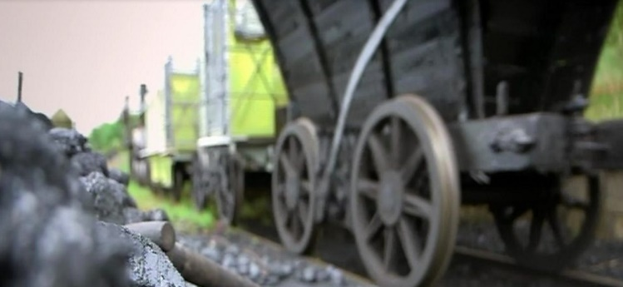
Listen to the story of The Stockton and Darlington Railway.
https://www.bbc.co.uk/programmes/p0151qsm

This week we want you to think about the impact of the railways. What have you discovered over the past 3 weeks?
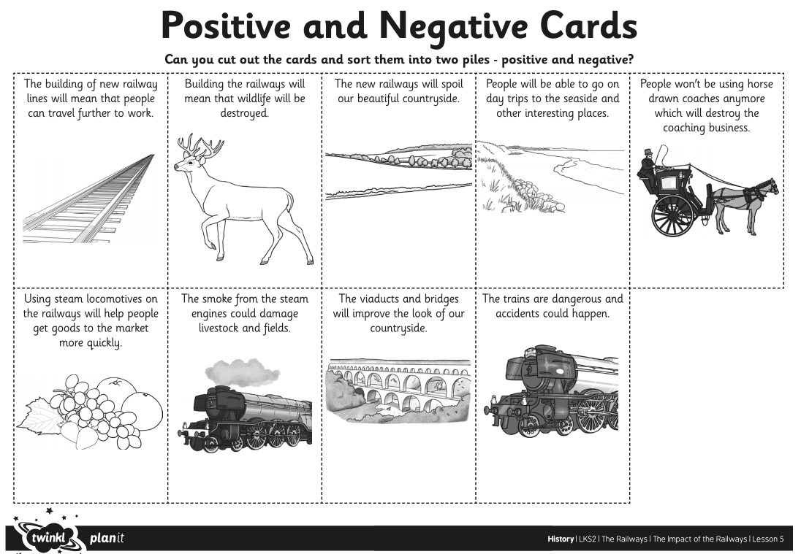
Did the railways have a positive (good) or negative (bad) impact on the lives and countryside of Great Britain?

