

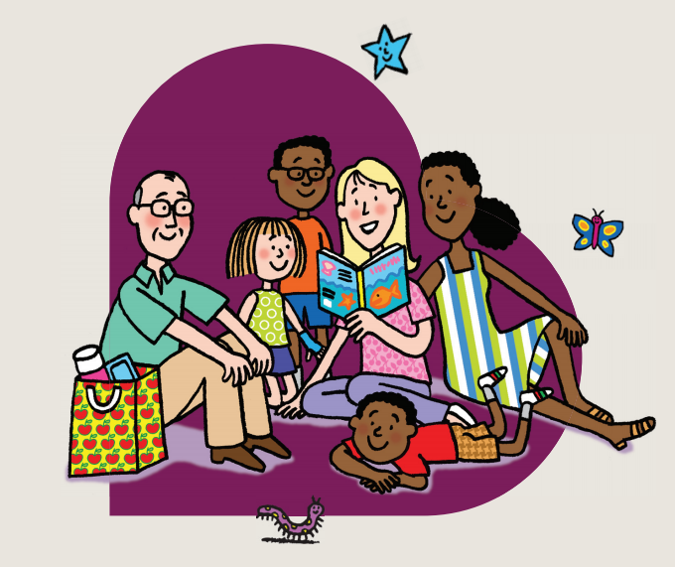

**Reading and Phonics Guide for Parents**

**It’s all about confidence…**   
For children to be good at maths, they need to feel confident about giving it a go. Praising your child for their effort, not their ability, will increase their confidence and make them hungry to learn more. In Maths, the process and thinking is as important as the calculation.

**Positivity is the key…**   
Children who succeed at maths are usually the ones who enjoy it most, so remember – maths is fun Yep – just keep telling yourself that, even if that’s not the way you remember it from your own childhood. We all know how easily children pick up on the things we say, so it’s vital that you don’t pass on your dislike or fear of maths by saying things like ‘I was never any good at maths’ or ‘I hated maths at school’ etc…

**Do maths together every day…**   
This might not sound very attractive, but you will be surprised by how much Maths you are already doing. Maths is everywhere – helping your child get dressed, baking together, going to the shops, singing counting songs, building with blocks – practically every activity we do with our children involves maths. All we need to do as parents is find the learning opportunities in these activities and we’ll be helping our children develop into happy and confident mathematicians! Challenging your child with their Maths is not about sitting down with more difficult calculations, asking more thoughtful questions can stretch their understanding.

This booklet outlines the key concepts we teach in Reception, end of year expectations and how you can help at home.

**In the street**

* Recognising bus numbers.
* Number plate hunt. Look for numbers in the plate – can you add them up?
* Comparing door numbers – look at odd and even, are the numbers getting bigger or smaller?
* Counting – how many lampposts on the way to school? How many metros pass? How many steps from the front door to the gate?

**Doing the washing**

* Counting in 2s – matching socks and counting them in pairs.
* Sorting items by colour and size – you could peg them out in size order.
* Matching/pairing up socks.
* Discuss the patterns you can see on socks/underwear/clothing.
* Find four shoes that are different sizes. Can you put them in order?
* Use different sized containers when washing the dishes – let children explore their capacity. Talk about full, half full, empty, nearly full.