West Jesmond Primary STEM Week Newsletter 7th -11th June 2021

Dear Parents and Carers,

It has been a very exciting week as across school we have been busily engaged in a wide range of activities for our annual STEM (Science, Technology, Engineering and Maths) Week.

This year, the themes were focused on our environment and active outdoor learning for our children. We have also been looking at some of the many careers related to our STEM theme and volunteers from Newcastle University created videos to share with our children talking about different roles in STEM subjects.

Throughout the week, we have been using the activities to develop our special Secret garden dedicated to the memory of a much loved and missed member of our West Jesmond Family, Deb Hainsworth.

In this week’s newsletter we will celebrate a selection of the learning and enjoyment that has taken place across school this week. We are very thankful for all of your support at home and the huge effort of Miss Jordan and Mr Jones bringing together all these great learning experiences.

Year 6 have been working hard this week answering their big question for STEM Week: What is beyond the garden?
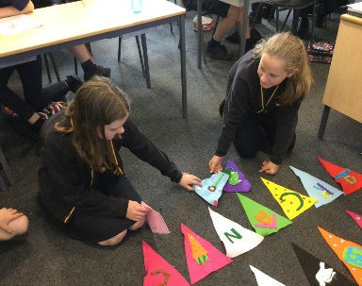
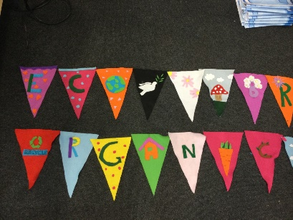
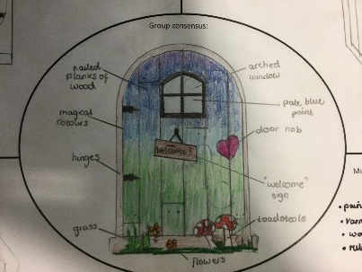
To do this, they designed, created and evaluated fairy doors that would be entrances to other worlds. They also created some fantastic 'Eco Themed' bunting that will be hung in our secret garden to make it bright and colourful.
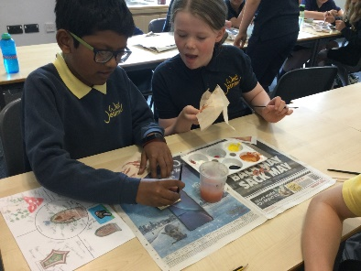

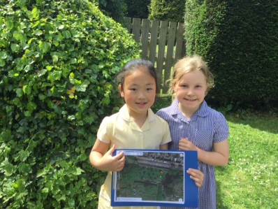
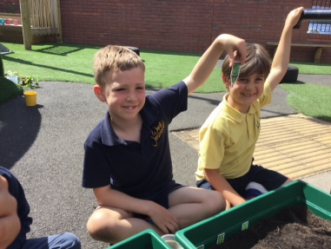
Year 2’s big question was ‘Which living things are to be found in our school yard?’
They have been planting seeds and herbs to begin creating our living wall and have filled our bug hotel. They have been out and about doing a habitat investigation at the orchard.

Year 5 have been thinking about the question ‘How can the garden be more sustainable?
Thank you to those families that donated bottle tops. They have been busy designing, refining and the using the recycled bottle tops to create a sign for the Secret Garden.
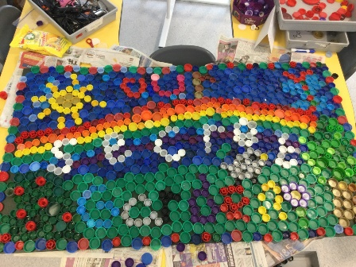
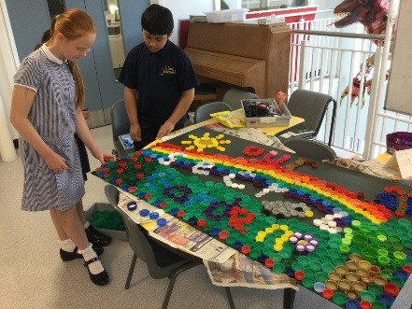
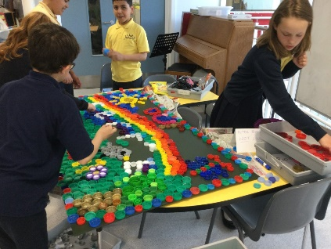

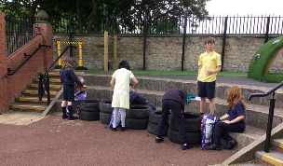
As part of Year 5's contribution to transforming the Secret Garden, they have also been starting to plant up some tyres that were donated to us from North Jesmond Garage in High West Jesmond.

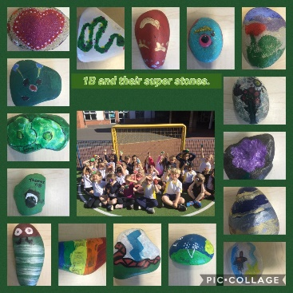
Year 1’s big question was ‘Which birds are in our locality?’
They investigated in school and in the orchard and graveyard to identify as many birds as possible and then made bird feeders to attract them into our school grounds.
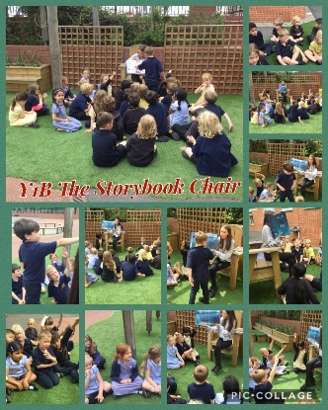
Year 1 also have joined with so many of our children in bringing in their decorated pebbles. Thank you to all of you at home with your support in creating such colourful and creative stones ready for our snake wall mosaic!

We have enjoyed lots of eco-based stories this week and where possible we have enjoyed them outside on our story chair! Here are Year 1 enjoying a story!
Thank you to Mincoff’s for supporting us again this year and especially for helping us to build up our stock of eco-themed books!

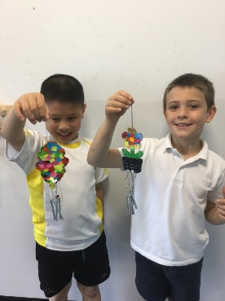
Year 4 discussed what sounds we would like to hear while in the Secret Garden and thought about what they might want to add to improve the soundscape of this beautiful space. They went on a sound walk around the orchard to investigate the natural sounds that we like and perhaps the unnatural ones that we don’t and used different materials to create relaxing sounds while planning how to design our own soundscape later on in the week. They then created these beautiful mosaic wind chimes. It took a lot of patience but they were really proud of the finished results!

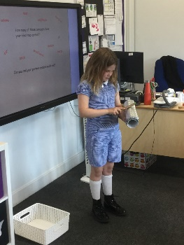
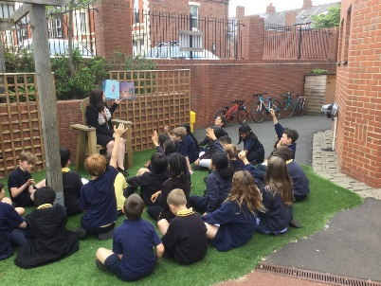
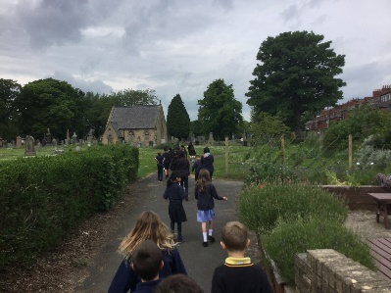
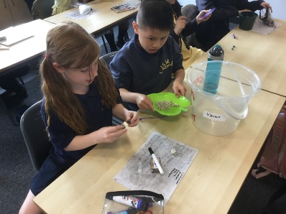

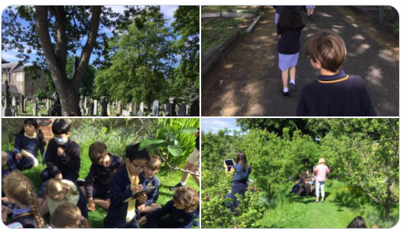
Year 3 had the challenge of finding out ‘how can we attract more birds into our Secret garden?’

They explored the orchard and graveyard to see which birds lived there and what their habitats were like before designing their bird feeders.

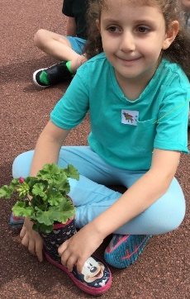
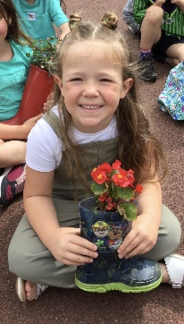
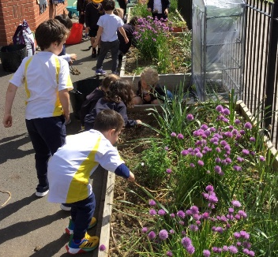
Reception were thinking about the big question ‘Where can we grow our plants?’
They designed and created terrific wellington planters to bring insects, birds into our garden and to fill it with colour and scents!

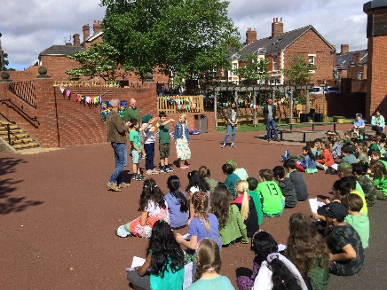
We finished the week with the whole school sharing their achievements, talking about the Secret Garden and singing our West Jesmond Eco Song in a series of outdoor assemblies!

Have a lovely weekend everyone!
Matt Ward (Headteacher)

